RABBIT SHOW ENTRY FORM
TRBA Fall Show
December 1 & 2, 2023 Killeen, Texas
trba.entry@yahoo.com
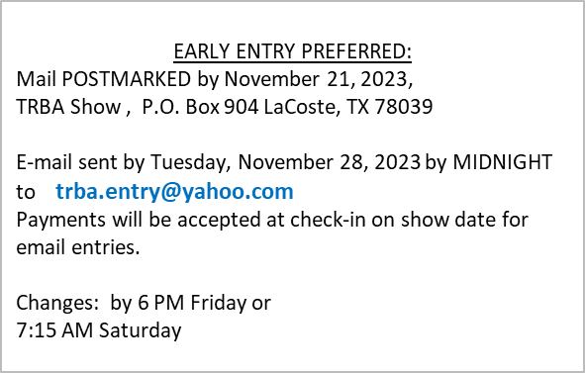
Exhibitor Name:
E-mail Address:
Phone Number:
Mailing Address:
City / State / Zip:
OPEN OR YOUTH:

Entries not Marked Open or Youth will be entered in Open

No | Tattoo | Breed | Variety | Class  Jr, Int, Sr | Sex | Fri. Show A | Sat AM  B | Sat  PM  C | Fur A | Fur B | Fur C
1 |  |  |  |  |  | ☐ | ☐ | ☐ | ☐ | ☐ | ☐
2 |  |  |  |  |  | ☐ | ☐ | ☐ | ☐ | ☐ | ☐
3 |  |  |  |  |  | ☐ | ☐ | ☐ | ☐ | ☐ | ☐
4 |  |  |  |  |  | ☐ | ☐ | ☐ | ☐ | ☐ | ☐
5 |  |  |  |  |  | ☐ | ☐ | ☐ | ☐ | ☐ | ☐
6 |  |  |  |  |  | ☐ | ☐ | ☐ | ☐ | ☐ | ☐
7 |  |  |  |  |  | ☐ | ☐ | ☐ | ☐ | ☐ | ☐
8 |  |  |  |  |  | ☐ | ☐ | ☐ | ☐ | ☐ | ☐
9 |  |  |  |  |  | ☐ | ☐ | ☐ | ☐ | ☐ | ☐
10 |  |  |  |  |  | ☐ | ☐ | ☐ | ☐ | ☐ | ☐
11 |  |  |  |  |  | ☐ | ☐ | ☐ | ☐ | ☐ | ☐
12 |  |  |  |  |  | ☐ | ☐ | ☐ | ☐ | ☐ | ☐
13 |  |  |  |  |  | ☐ | ☐ | ☐ | ☐ | ☐ | ☐
14 |  |  |  |  |  | ☐ | ☐ | ☐ | ☐ | ☐ | ☐
15 |  |  |  |  |  | ☐ | ☐ | ☐ | ☐ | ☐ | ☐
 |  |  |  | Total

By means of entry, I acknowledge and accept the risks associated with Covid and RHDv2, and will hold harmless all members of the TRBA Team. I will follow all regulations as set forth by the City, County, State and National mandates for Covid Protection & by the ARBA for RHDv2.

